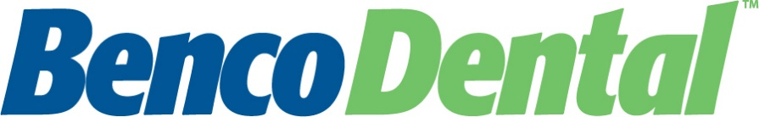

TO: Valued Customer

FROM: Amy M. Yando, Director of Tax
570-602-7049
ayando@benco.com

SUBJECT: Sales Tax Exemption Certificate

Benco recently completed an internal audit of state sales tax as applied to dental lab purchases.

Products associated with the categories listed on the following page are subject to taxation in the State of Virginia, unless a valid exemption certificate has been executed. To facilitate the exemption process, please furnish Benco with a copy of the Virginia Exemption Certificate, ST-11.

To view an example of your state’s completed certificate, please visit the following link:
https://www.benco.com/equipment/benco-lab/exemption-certificate-information/. This example will provide you with the necessary fields that require completion. Additionally, we have included a blank copy of your state’s exemption certificate.

Please send a copy of your completed exemption certificate to the Benco Tax Team ASAP. You may do so by fax, email, or by USPS. Please make sure that your customer number, contact name, and phone number are clearly indicated at the top of your form, in case we require any clarification.

Email: Tax@Benco.com
Fax: 570.602.5847
USPS: SALES TAX DEPARTMENT
Benco Dental
P.O Box 491
Pittston, PA 18640

Benco is committed to always providing the highest level of service. We value your business and appreciate your continued support.

